worksheet 4: Body part measuring in Europe
Resources: worksheet 4
Focus on content: measures
Focus on languageS: dictionary skills + French, Czech, Italian, English 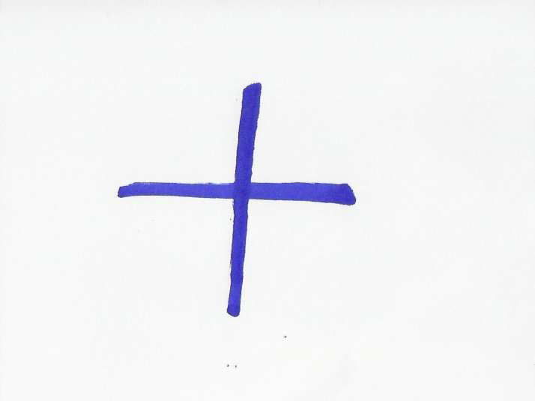
Timing: 25 minutes
Grouping: 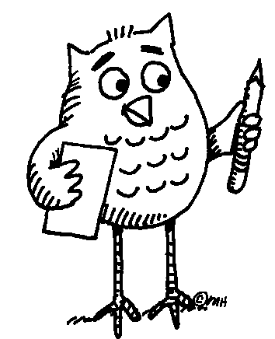 | ... Learners work in pairs. After finishing task 4, they share their results with the others in class.

Learner worksheet 4: BODY PART MEASURING IN EUROPE



Task 1: Read the text using the dictionary to clarify the meaning of unknown words.
“ … 4 fingers make a palm, and 4 palms make a foot; 6 palms make 1 cubit, 4 cubits make a man's height, and 4 cubits make one pace ... “
From: The Notebooks of Leonardo da Vinci (original edition 1883).
Task 2: Measure yourself or each other to verify the above statement.
Task 3: Compare the names of measures in English, Czech, French and Italian. Complete the table below.
4 doigts font une paume, et 4 paumes font un pied; 6 paumes font une coudée, 4 coudées font la taille d’un homme, et 4 coudées font un pas ...
4 diti fa un palmo, e 4 palmi fa un pie; 6 palmi fa un cubito, 4 cubiti fa un homo, e 4 cubiti fa un passo ...
4 prsty představují dlaň a 4 dlaně jsou jedna stopa; 6 dlaní představuje 1 loket, 4 lokte představují výšku člověka a 4 lokte představují i krok …
ENGLISH CZECH FRENCH ITALIAN YOUR LANGUAGE
4 fingers
a palm
a foot
1 cubit
... Follow up activity for the whole class:
Can you give examples of body part counting or measuring in your culture?
Notes for the teacher: Worksheet 4
Task 3 - Answer sheet:
ENGLISH CZECH FRENCH ITALIAN
4 fingers 4 prsty 4 doigts 4 diti
a palm dlaň une paume un palmo
a foot stopa un pied un pie
1 cubit loket une coudée un cubito
Additional information:
- Not all body parts translate directly into measures, e.g.
English: 1. elbow (body part), 2. cubit (an ancient unit of length equal to the length of the
arm between the wrist and the elbow)
Czech: loket [loket] = both a body part and an old unit of length
- In some languages, number 1 is expressed by an indefinite article.
Follow up activity:
It is advisable that the learners share their results with the others. To do this, the teacher can use the board or other means. Even though this is primarily a writing task, the learners can be encouraged to pronounce “their” words. They should also tell the others if these units of length are used in their culture and how.
References:
Favilli, F. (ed.). Lower Secondary School Teacher Training in Mathematics. Comparison and best practices. Pisa: Edizioni Plus – Pisa University press, 2006, p. 145. lim.dm.unipi.it
The Notebooks of Leonardo da Vinci, Vol. 1 (of a 2 vol. set in paperback) pp. 182-3, Dover, ISBN 0-486-22572-0 (J. P. Richter, original edition 1883).

